**SHADOW BOX Test  
VISUAL MERCHANDISING**

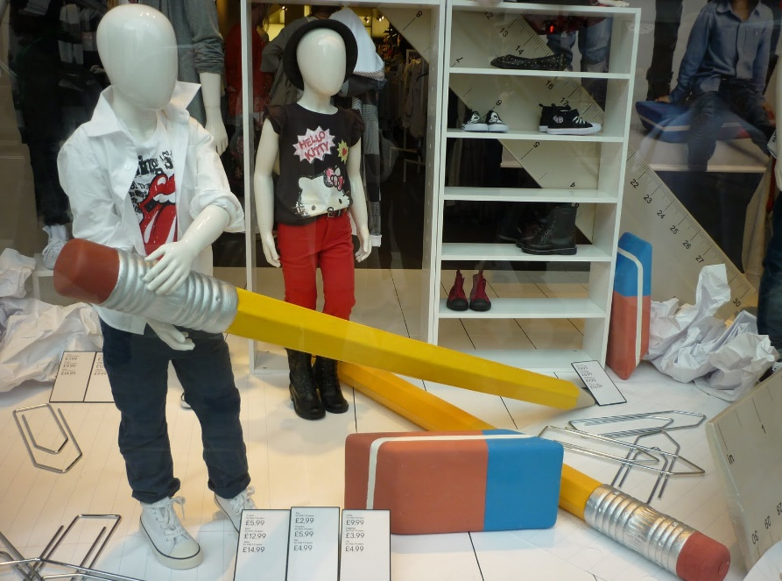**Materials:** Push pins, markers, Sketch board and pad, construction paper, foam board, clear fishing line, yarn, other supplies brought by students. A PowerPoint Presentation to document your ideas to share with class.

**Objective:** Create a mock-up of your Window Display ideas for the school store window based on the month you choose. Your theme must be approved by Mrs. Vetter.

**Directions** – Plan and Create a shadowbox (idea box) of your window display to go along with your theme. This will be a mockup of what it will look like and the colors and themes you have chosen.

Detail your design ideas in a PowerPoint, google slides or Canva Presentation. This will be present to the class as if you are pitching an idea to a business owner to display their products in their window (4 – 5 slides minimum). Present your ideas to the class. The class will determine the best ideas!

**Task #1** – Select the merchandise that you will use in your display based on the products in the store. List ideas below:

|  |
| --- |
| Item |
|  |
|  |
|  |
|  |
|  |
|  |
|  |

**Task #2** – Select the type of Display you will use (one, similar, related, or cross mix).

**Task #3 –** Use google images to gather ideas for designing your window. Example, if you are doing a Halloween theme, google Halloween window displays and select on the images in google. The goal would be to select displays that will be cost effective. Select three photos that you think would work in our windows with the products you chose above. Print these out and attach them to this document. You must also use these in the PowerPoint slides as a description of where you got some of your ideas.

**Task #4** - Select your Setting (realistic, semi-realistic, or abstract)

**Task #5:** Decide on your visual theme. It can be for a holiday, a time of year (i.e. fall, an event, homecoming etc.). In your presentation, type a slide that includes your theme idea and justification on why this theme should be placed in store windows.

**Task #6 – What artistic elements will you use -** what props will be used, what decorations, special lighting, lines etc.… what colors etc. Are you going to use mannequins, signage, or graphics. Be sure to add at least 3 – 4 of these. Determine all the supplies you will need to purchase/make/find to complete your window. Include a list of any special features, props, signs, decorations you will use, where you will get these supplies, and an approximate cost.

**Task 7:** List what presentation method you would use (groups of 3, pyramid, or idea).

**Task #9** **– Budget:** List all items below that you would need to acquire to create your window (from above). Also, what will each item cost that needs to be purchased. Some of these items are listed above within the charts. Carry these down to this table to get a full budget sheet.

|  |  |  |
| --- | --- | --- |
| Item | Where to purchase | Approximate cost |
|  |  |  |
|  |  |  |
|  |  |  |
|  |  |  |
|  |  |  |
|  |  |  |
|  |  |  |

**Task #10: Create a Shadow box of your idea and a PowerPoint to pitch your idea. The PowerPoint would be your pitch presentation to the business of how they could present their products in our widow display. The Shadow Box would be your example.**

**Presentation Rubric:**

|  |  |  |
| --- | --- | --- |
|  | **Points Possible** | **Points Received** |
| **Ideas Rubric** | | |
| Selected appropriate merchandise | 5 |  |
| Select a Display Type (one, similar, related, cross mix) | 5 |  |
| Theme was clear, appropriate and justified based on product and month selected | 5 |  |
| Identified and used artistic elements that caught the attention of the customers.  Color and Texture were appropriate  Lines and Composition  Signage  Graphics  Mannequins  Props  Decorations | 10 |  |
| **PowerPoint Rubric:** | | |
| Included a description of your visual merchandising idea. | 5 |  |
| Described the Elements you will use – props, signs, decorations, graphics, mannequins etc. | 10 |  |
| Included a Budget table with the items needed to complete your project along with cost and where to purchase. | 10 |  |
| Included, pictures from google to show where your ideas came from. | 5 |  |
| Included a presentation option (Rule of 3, Pyramid, etc. 7 to choose from) | 5 |  |
| **Other Points** | | |
| Overall Neatness and Creativity | 10 |  |
| Class Participation – Each student in group helped present. | 10 |  |
| Shadowbox: Mockup of your ideas were neat and easy to visualize and created a clear depiction of what you would do. | **10** |  |
|  | **10** |  |
| **Total** | **100** |  |

January

February

March

April

May

Nov

Dec